Orthopaedic Guidance Hub — Project Overview

Introduction
The Orthopaedic Guidance Hub is an early-stage prototype digital tool developed with the PRUH orthopaedic team in mind to make orthopaedic guidance easier to find and use in day-to-day clinical practice. It provides a simple, mobile-friendly, searchable front door to relevant national and specialist-society guidance for use in ward, clinic, and on-call settings. This helps clinicians navigate guidance that is currently spread across multiple organisations, websites, and document types.
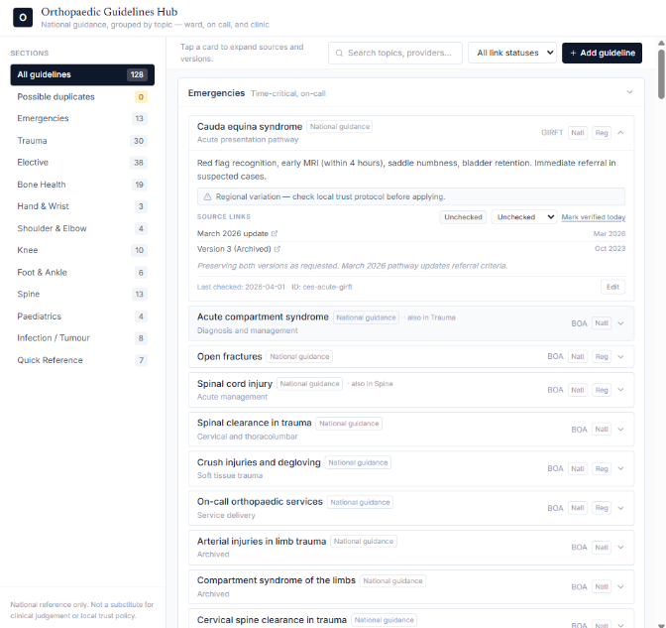Fig 1: Guidelines library — grouped by clinical section, searchable, with source links and version tracking. | 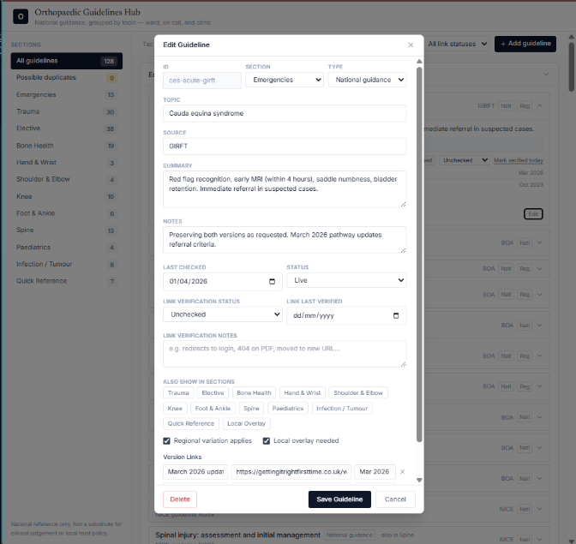Fig 2: Guideline entry detail — source, summary, review status, and linked versions.

What the prototype currently offers
The current version of the hub:
- groups guidance by relevant clinical section and topic
- allows quick browsing and search
- links directly to original source documents
- creates a more coherent and accessible navigation layer across multiple guidance providers
The tool is intended to help clinicians reach relevant guidance more efficiently, rather than replace the source material itself.

Why it is useful
In busy clinical environments, guidance can be difficult to locate quickly despite already existing. A tool that improves access, visibility, and organisation has the potential to make day-to-day practice more efficient and more consistent, particularly for junior clinicians and teams working across different settings.

Current position
The project is currently a first-draft prototype and has been shared locally for early feedback. The response so far has been encouraging, and the next step is to refine it into a stronger final draft while clarifying the appropriate governance, licensing, and maintenance arrangements needed before any wider rollout is considered.
Following this initial feedback, I have also been encouraged to explore what an app-based or more formal mobile version of the tool could look like in the future, once the core web-based model has been refined.
The project is being shaped to ensure any future expansion is supported by appropriate governance, licensing, and maintenance arrangements

Next steps
The next stage of work is focused on:
- refining the prototype into a stronger final draft
- clarifying IP, licensing, and publication considerations
- defining a realistic maintenance and ownership model
- gathering more detailed feedback on what would make the tool most useful in practice
- exploring whether a mobile app or app-like version would be appropriate at a later stage

About the project lead
Safa Saheer, a Biomedical Science student and the originator of the Orthopaedic Guidance Hub, developed as an early-stage digital project to improve access to orthopaedic guidance at PRUH

